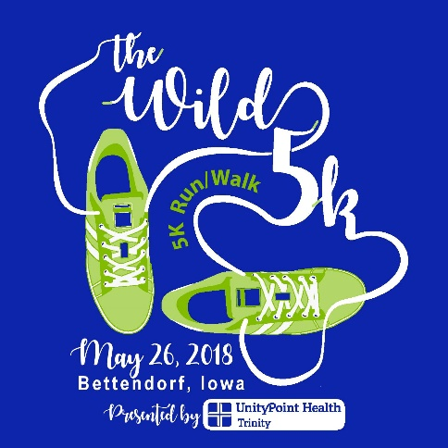
Saturday, May 26th, 2018
8:00 A.M.
Unity Point Health-Trinity
Bettendorf, Iowa

Benefiting

Bethany for Children & Families

Sponsored by:

Running Wild – Unity Point Health- Arconic - Jim’s Equipment Service - Rock Valley Physical Therapy - Bethany for Children & Families - Cornbelt Running Club - Hawkeye Ice – Art-O-Lite Electric –
Accusplit - Russell Construction - Sheet Metal Workers Local 91- Group Services – Jewell-Osco – IBEW Local 145
Quad City Times – Nelson Brothers Agency - SpeedConnect – Quad City Bank & Trust - Kale Co.
LE Chute - WVIK / Quad Cities NP - Ascentra Credit Union - Whiteys Ice Cream - HyVee

- Location: Unity Point Health-Trinity Hospital, 4500 Utica Ridge Road, Bettendorf, IA, 52722.
- Course: Out and back course starting at UnityPoint Hospital, Utica Ridge Rd., go east on Crow Creek Road several blocks past 18th St., then west back to Trinity. Scenic neighborhood streets with moderate hills on Crow Creek Rd.
- Post Race Party: In the Unity Point Health-Trinity Healing Garden. Food, Refreshments, Music, Awards. Enter from the far south parking lot.
- Awards: Awards to overall male and female and first 3 places in the following age groups: 0-19, 20-24, 25-29, 30-34, 35-39, 40-44, 45-49, 50-54, 55-59, 60-64, 65-69, 70- & over.
- Chip Timing: Provided by Accusplit.
- T-shirts: Short sleeve Asics coolmax tee to all registered runners. Available in sizes XS, S, M, L, XL, XXL. XXL an additional $2.
- Parking: Use the far south parking lot by the medical office building. Follow the parking volunteers and parking signs.
- Restrooms: Participants are welcome to use the restrooms inside Unity Point Health-Trinity.
- Registration Fees: $26.00 if pre-registered by May 21. After May 21, cost is $30.00. All paid entrants are guaranteed a tee shirt. Additional donations to Bethany for Children and Families are very much appreciated.
- On-line Registration: Register at www.runningwildusa.com
- Packet Pick-Up/Registration: Friday, May 25th, 10 am to 7 pm at Running Wild, 3216 N. Brady St., Davenport, IA. The phone number is 563-323-7025. On race day 6:30 – 7:45 am, packets can be picked up in the cafeteria at Unity Point Hospital. Enter through the main lobby and go downstairs to the cafeteria.

CBRC Race Circuit Race

Mail entry to Running Wild, 3216 N. Brady St., Davenport, IA 52803
Make checks payable to Running Wild

Name: __________________________________Birthdate:________________ Age on May 26, 2018: ____
Address: _______________________________________City________________State_____Zip________
Phone: _______________________________________________ Gender (please circle): Male Female
Shirt Size- Unisex sizing (please circle): XS S M L XL XXL (additional $2 for XXL)
Fees: Pre-registered by May 21, 2018……………………………………………………..$26
After May 21, 2018……………………………………………………………………….$30 WILD “5”
Size XXL t-shirt………………………………………………………………………..…$32

Waiver: I know that running/walking a road race is a potentially hazardous activity. I should not enter unless I am able. I assume all risks associated with this event including and not limited to falls, injuries, and contact with other participants, effects of weather, traffic and road conditions. I, for myself and anyone entitled to act on my behalf, waive and release The Wild 5 Run, race officials, organizers, sponsors, volunteers, the cities of Bettendorf and Davenport and its employees and contractors from all claims and liabilities. I further state that I have trained accurately and am in suitable athletic condition to compete in the race I have entered.

Signature: ____________________________________________________ Date: ___________________

SHORT SLEEVE ASICS
COOLMAX TEE-SHIRTS

